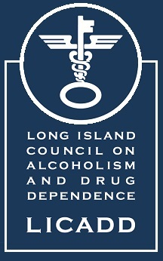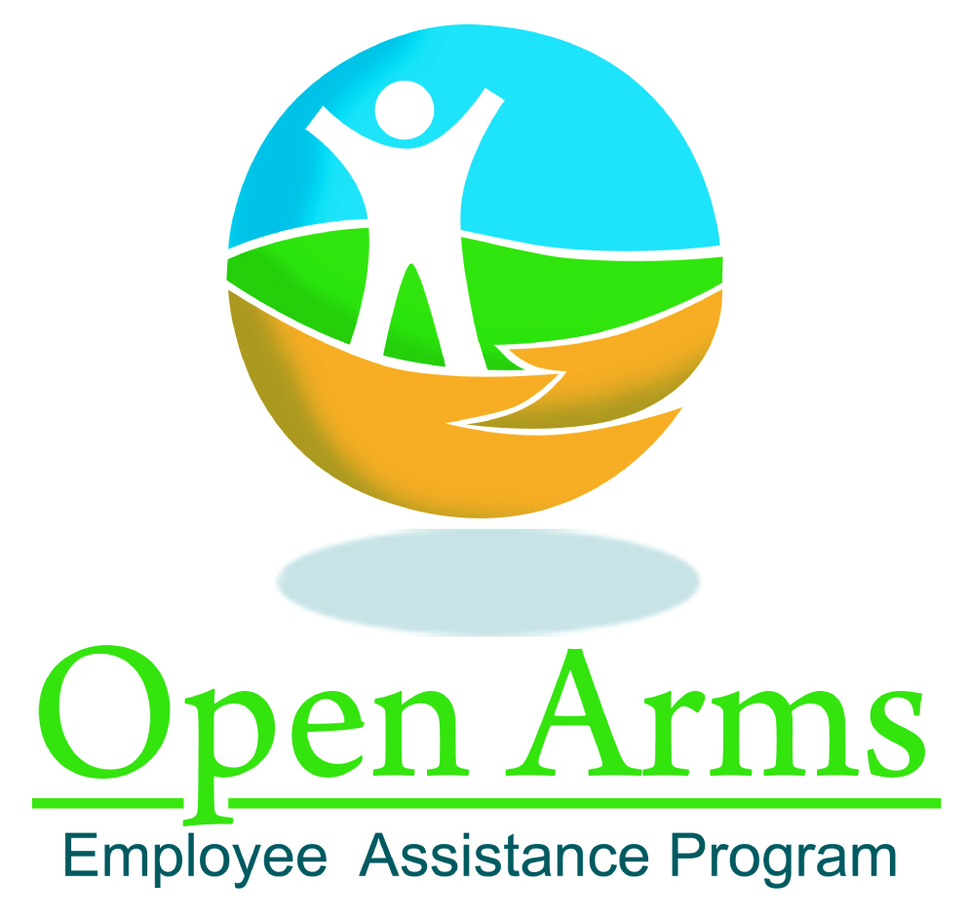

Long Island Council on Alcoholism and Drug Dependence, Inc.

Open Arms- Employee Assistance Program Director- Job Description

Position Summary:
The EAP Director is responsible for managing all operational aspects of the regional EAP subsidiary business, including clinical services delivery both telephonically and in-person, management and organizational consulting services, account management activities, critical incident and psychological first aid response, and organizational services delivery (e.g., training, coaching, conflict resolution, and organizational development offerings).
The Director works collaboratively with the Executive Director and Director of Programming to effectively oversee and manage strategic and fiscal accountabilities at the EAP subsidiary level. The Director cultivates and maintains excellent relationships with EAP staff, customers, vendors, the business community, and corporate stakeholders to ensure the fulfillment of the subsidiary and EAP enterprise-wide goals.

Primary Responsibilities:
- Network and market Open Arms through any means; memberships, referrals from current clients, individuals in HR field, EAPA committees
- Design sales strategy, create sales brochure and any other collateral materials
- Continue to develop EAP trainings which currently has over 65+ trainings in areas of Health and Wellness, Performance, Leadership and Management, Customer Service and Workplace and HR Training
- Continue to expand and update Open arms website in order to attract new business as well as keep up-to-date on new and relevant information and services for employers/employees to access
- Develop, implement, and evaluate a strategic plan and annual objectives, assuring quality service delivery and manageable growth, strategic planning.
- Prepare the annual program budget and monitor expenses monthly, .
- Develop and implement standard operating procedures and practices for EAP service delivery that ensure client confidentiality and timely, ethical and quality service.
- Establish and maintain effective and confidential record keeping system and data-management reporting system.
- Stay abreast of latest workplace issues, EAPA policies for EAP professionals by attending the annual EAPA World Conference for networking and continued education
- Maintain a good working relationship with all contracts; providing HR with consultations
- Continue to review pricing structure to stay competitive and profitable, invoicing and follow up on all contracts; renegotiation of price upon renewal
- Supervision of EAP Team; team building; annual evaluations
- Individual, couple or family sessions with EAP clients when needed; especially mandates and high profile cases.
- Effectively represent LICADD and Open Arms EAP system with clients, business customers and the community. Participate in relevant professional organizations and provide consultation regarding EAP and OD practice to the regional business communities serviced.

Qualifications and Skills:
- LCSW or LMHC for NYS- required
- CEAP and/or SAP credential- preferred
- Minimum of 5 years’ experience with demonstrated competency in providing EAP services, clinical supervision, account management, outpatient mental health treatment modalities, alcohol and/or chemical dependency treatment, inpatient psychiatric practice, and private psychotherapy practice.
- Time management
- Microsoft office proficiency
- Detail oriented

EAPA Core Technologies

- Consultation with, training of, and assistance to work organization leadership (managers, supervisors, and union officials) seeking to manage troubled employees, enhance the work environment, and improve employee job performance;
- Active promotion of the availability of EA services to employees, their family members, and the work organization.
- Confidential and timely problem identification/assessment services for employee clients with personal concerns that may affect job performance;
- Use of constructive confrontation, motivation, and short-term intervention with employee clients to address problems that affect job performance;
- Referral of employee clients for diagnosis, treatment, and assistance, as well as case monitoring and follow-up services;
- Assisting work organizations in establishing and maintaining effective relations with treatment and other service providers, and in managing provider contracts;
- Consultation to work organizations to encourage availability of and employee access to health benefits covering medical and behavioral problems including, but not limited to, alcoholism, drug abuse, and mental and emotional disorders; and
- Evaluation of the effects of EA services on work organizations and individual job performance.

